Big Query

Create Dataset : Workshop6

Create Table : 1. Source Google cloud storage ใช้ไฟล์ workshop 5

2. วิธีที่สอง upload ผ่าน cloud shell

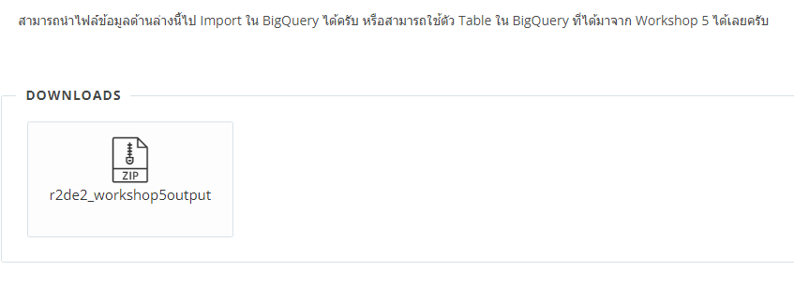

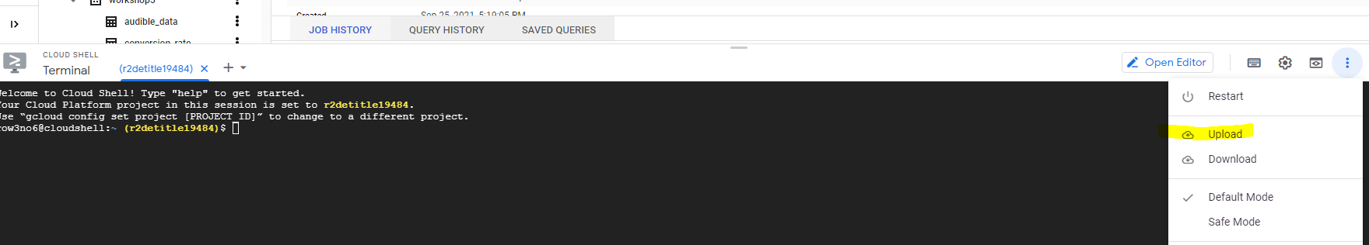

row3no6@cloudshell:~ (r2detitle19484)$ unzip r2de2_workshop5output.zip

Archive: r2de2_workshop5output.zip

inflating: workshop5output.csv

row3no6@cloudshell:~ (r2detitle19484)$ ls

airflow new_data.zip start_ws4_exercise1.py start_ws4_exercise3_loop.py start_ws5_bq_load.py workshop3_download.csv ws2-output.csv

asia-east2-workshop5-635b7826-bucket r2de2_workshop5output.zip start_ws4_exercise1_taskflow.py start_ws4_exercise3.py start_ws5_gcs_to_bq.py workshop3.py

data.zip README-cloudshell.txt start_ws4_exercise2.py start_ws4_exercise4.py upload_file.py workshop5output.csv

กด Authorize

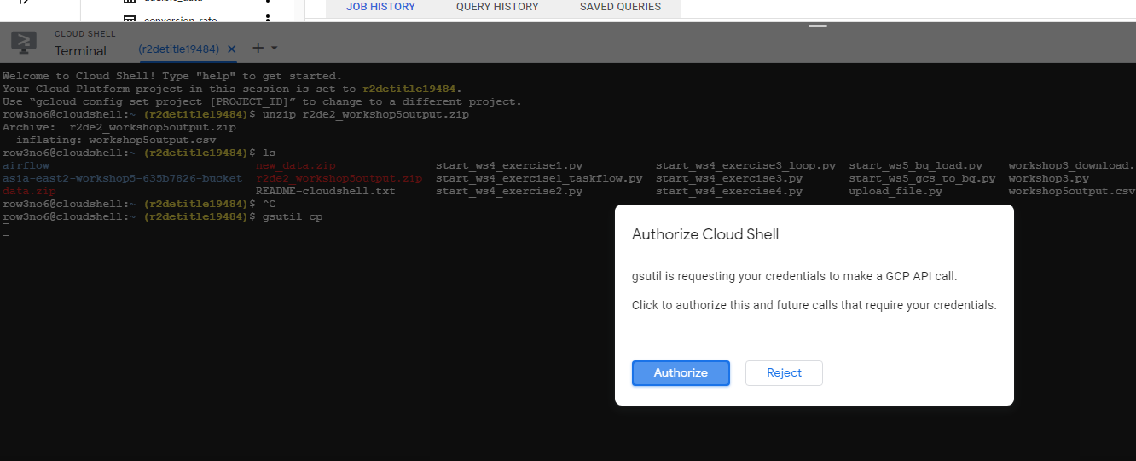

Copy file to data lake

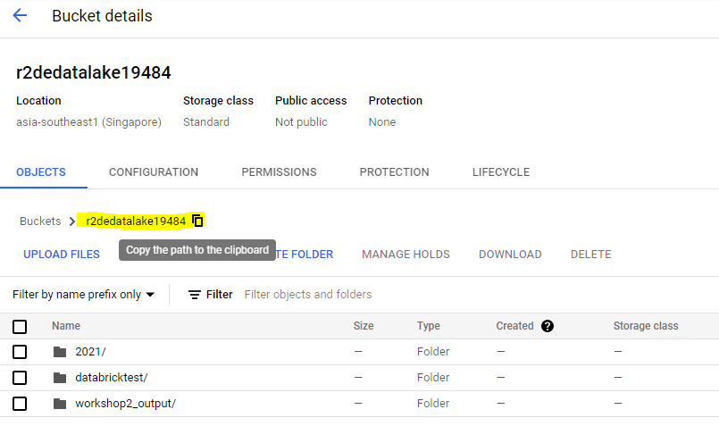

row3no6@cloudshell:~ (r2detitle19484)$ gsutil cp workshop5output.csv gs://r2dedatalake19484

Copying file://workshop5output.csv [Content-Type=text/csv]...

==> NOTE: You are uploading one or more large file(s), which would run

significantly faster if you enable parallel composite uploads. This

feature can be enabled by editing the

"parallel_composite_upload_threshold" value in your .boto

configuration file. However, note that if you do this large files will

be uploaded as `composite objects

<https://cloud.google.com/storage/docs/composite-objects>`_,which

means that any user who downloads such objects will need to have a

compiled crcmod installed (see "gsutil help crcmod"). This is because

without a compiled crcmod, computing checksums on composite objects is

so slow that gsutil disables downloads of composite objects.

- [1 files][418.0 MiB/418.0 MiB]

Operation completed over 1 objects/418.0 MiB.

row3no6@cloudshell:~ (r2detitle19484)$

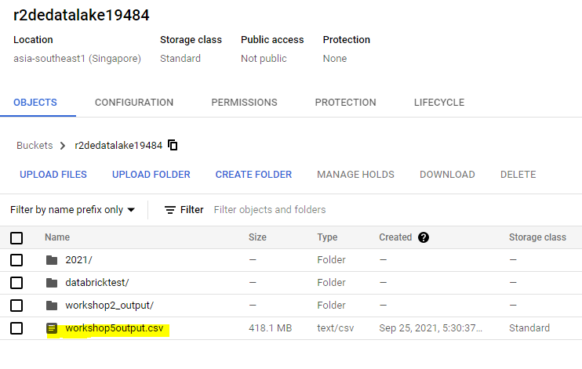

กลับไป Big Query

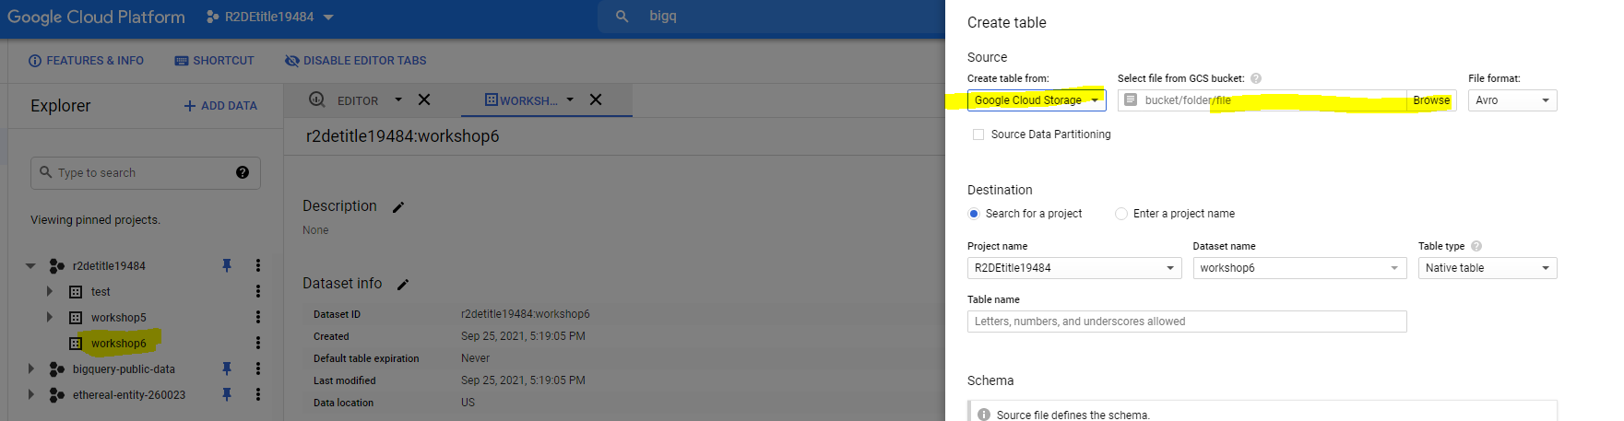

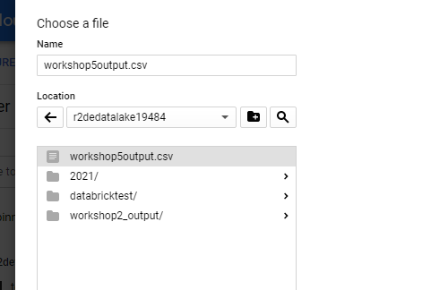

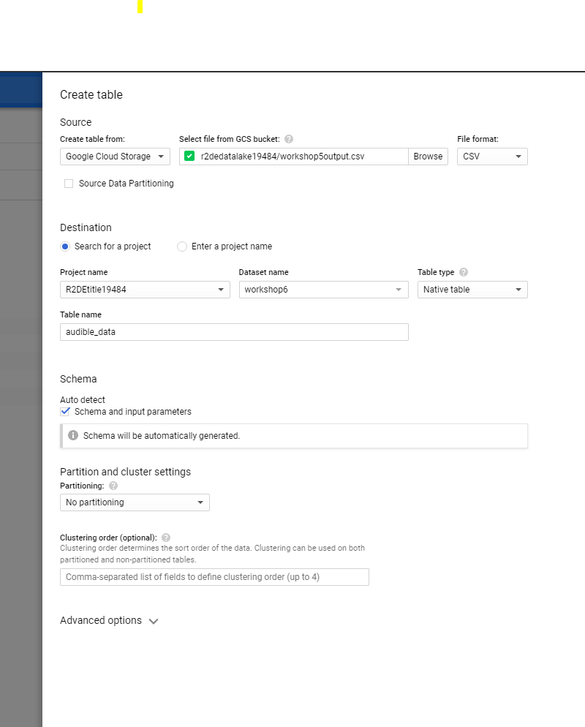

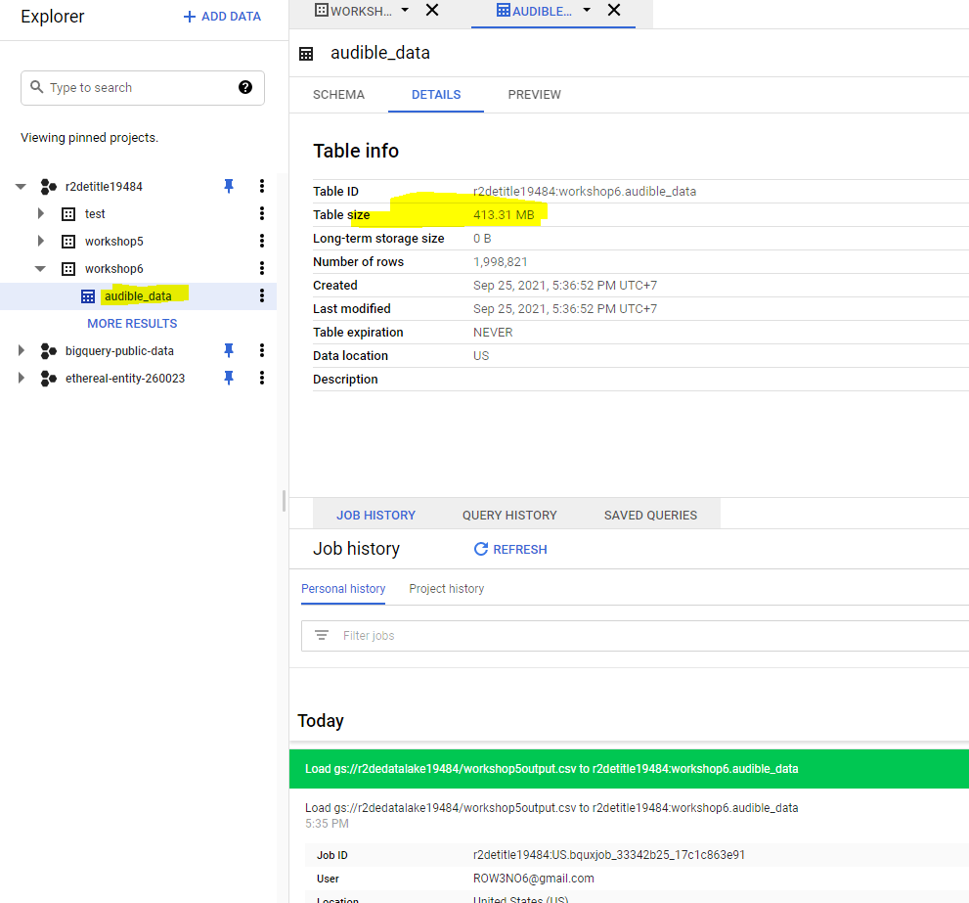

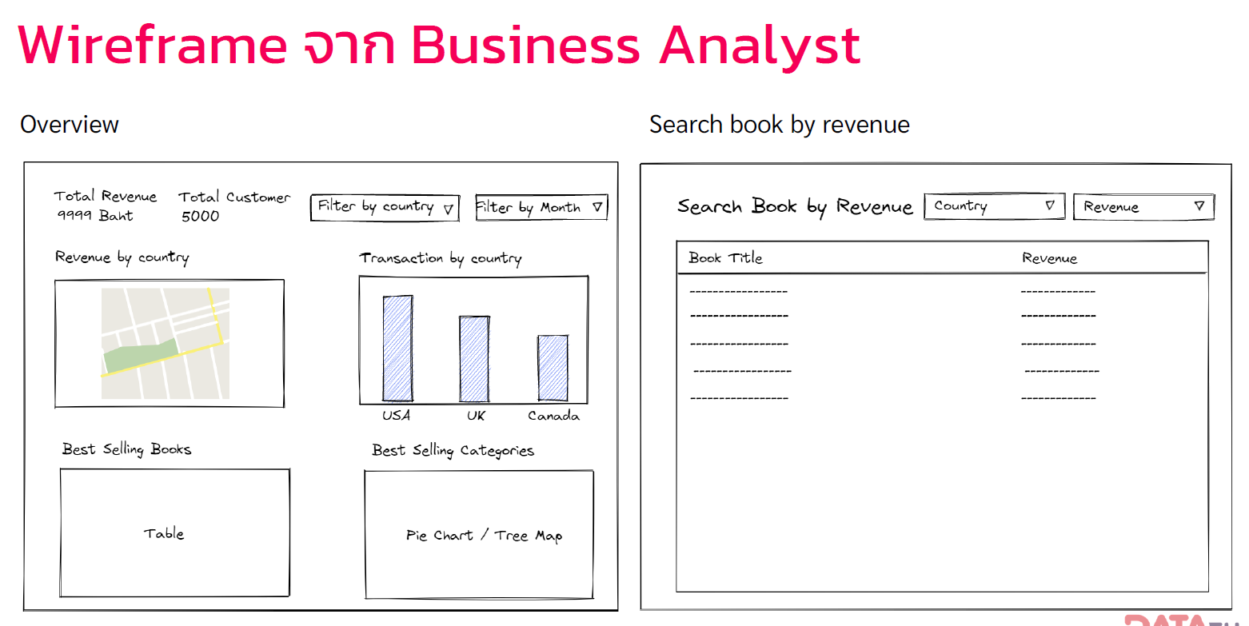

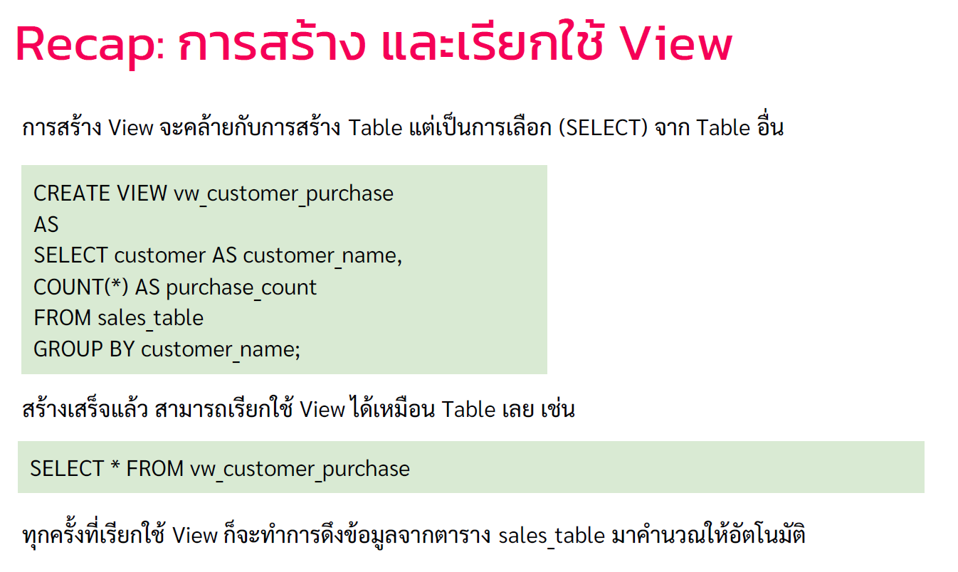

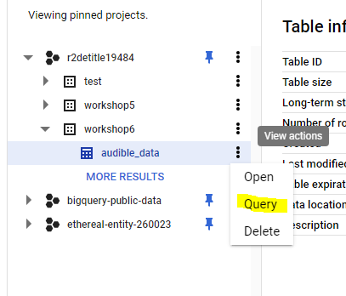

CREATE VIEW `r2detitle19484.workshop6.vw_ws6`

AS

SELECT timestamp , user_id , country  , Book_ID , Book_Title , Categories , THBPrice

FROM `r2detitle19484.workshop6.audible_data`

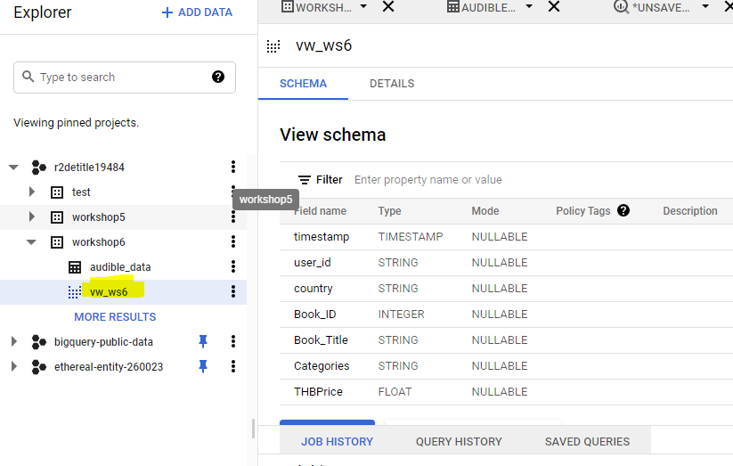

<https://datastudio.google.com/u/0/>

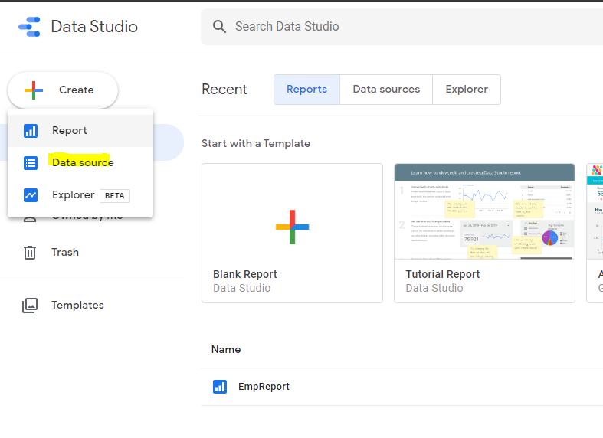

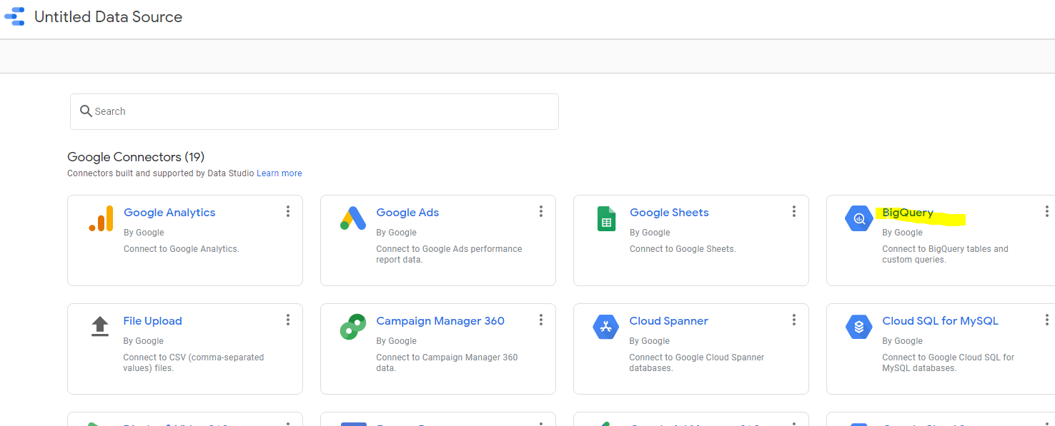

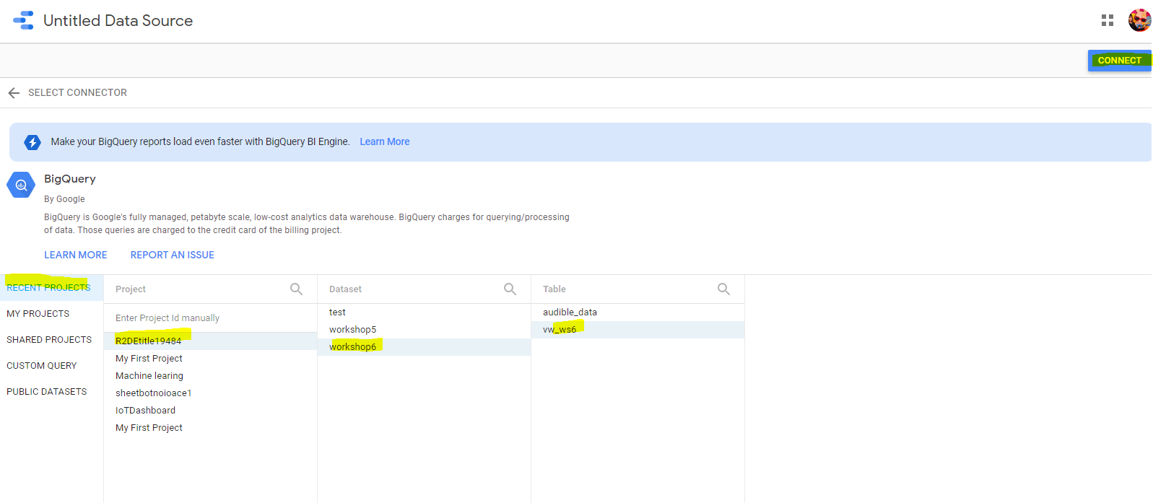

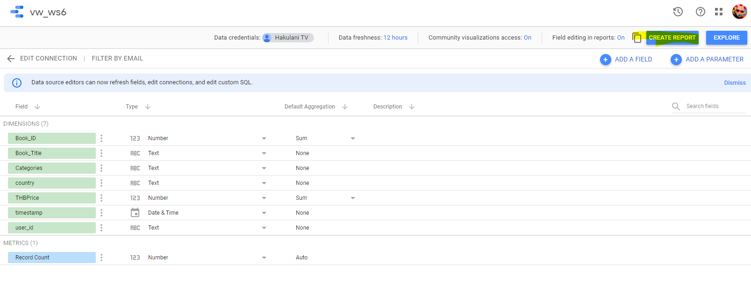

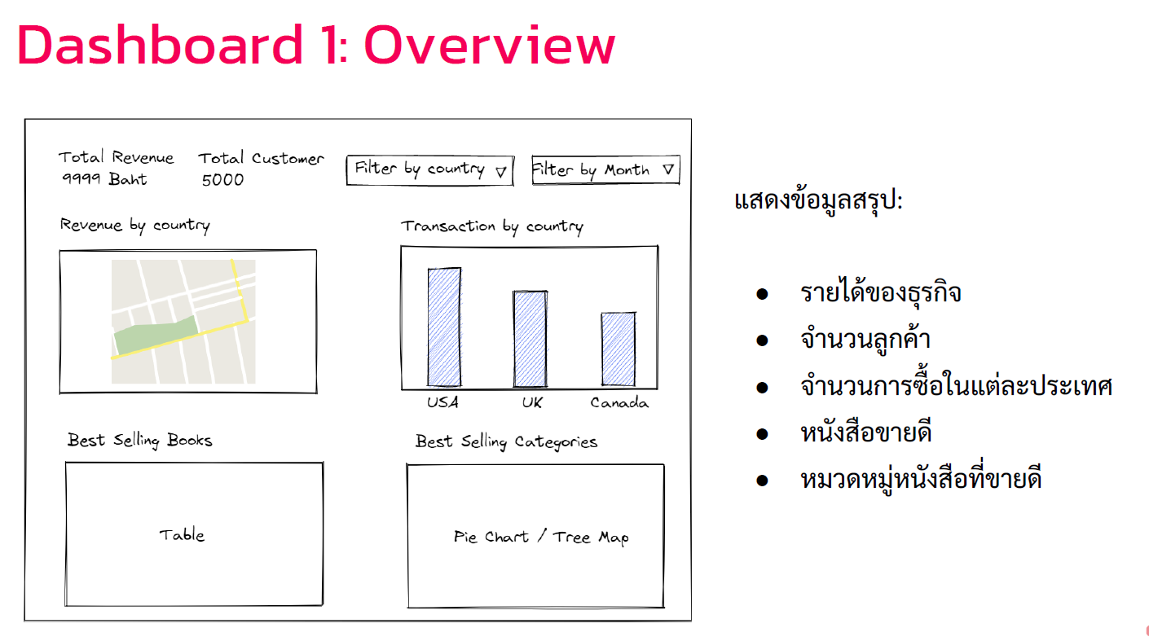

Clear Report

Rename : WS6 Workshop Run Through

Add a chart > Scorecard

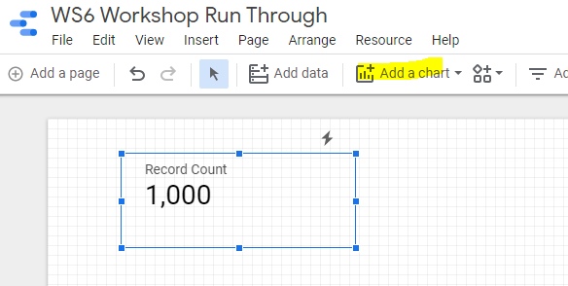

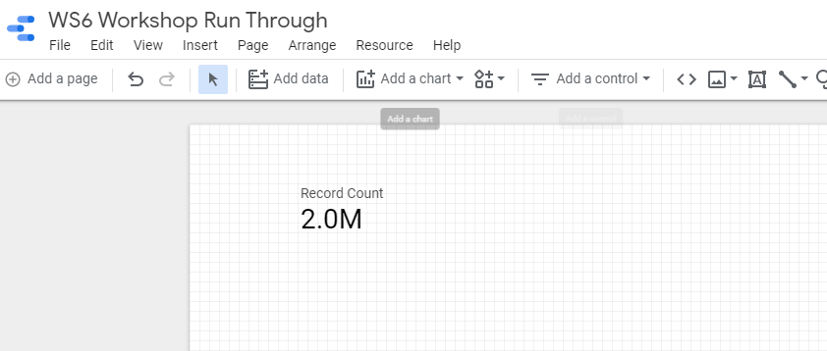

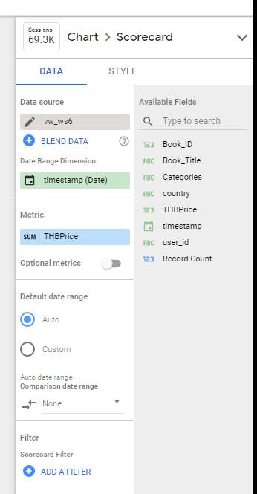

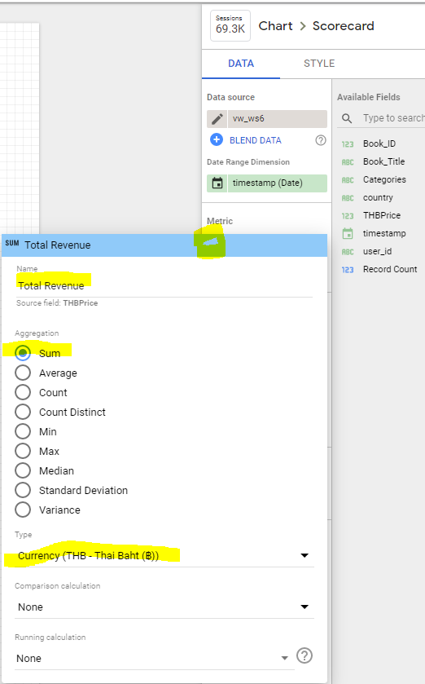

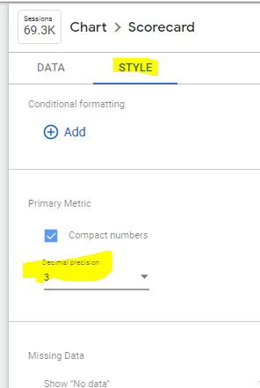

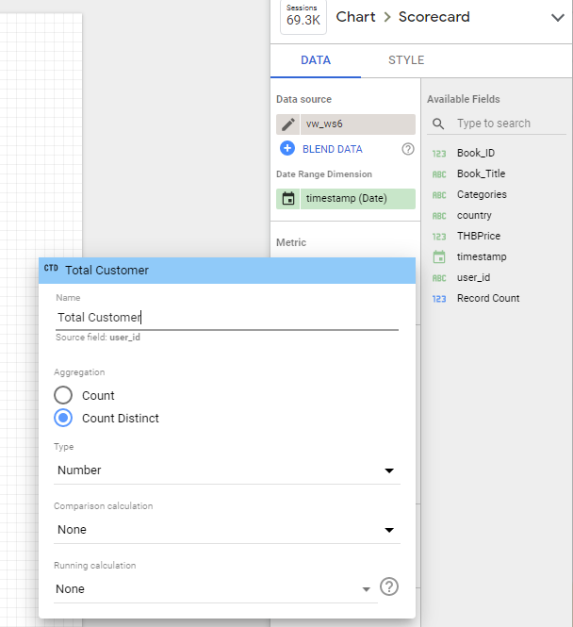

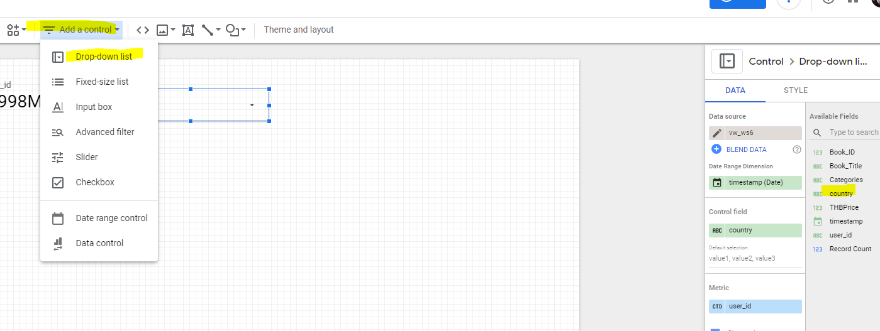

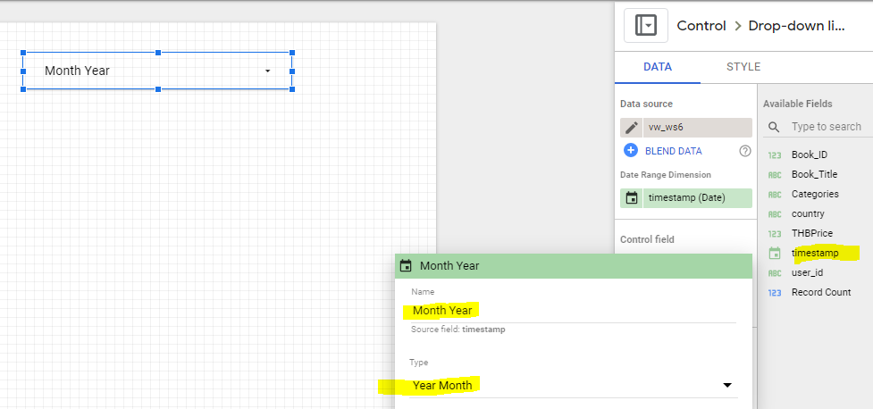

Insert > Text > Revenue by Country

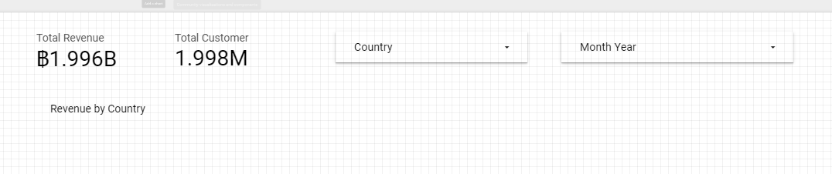

Add Chart > Google map

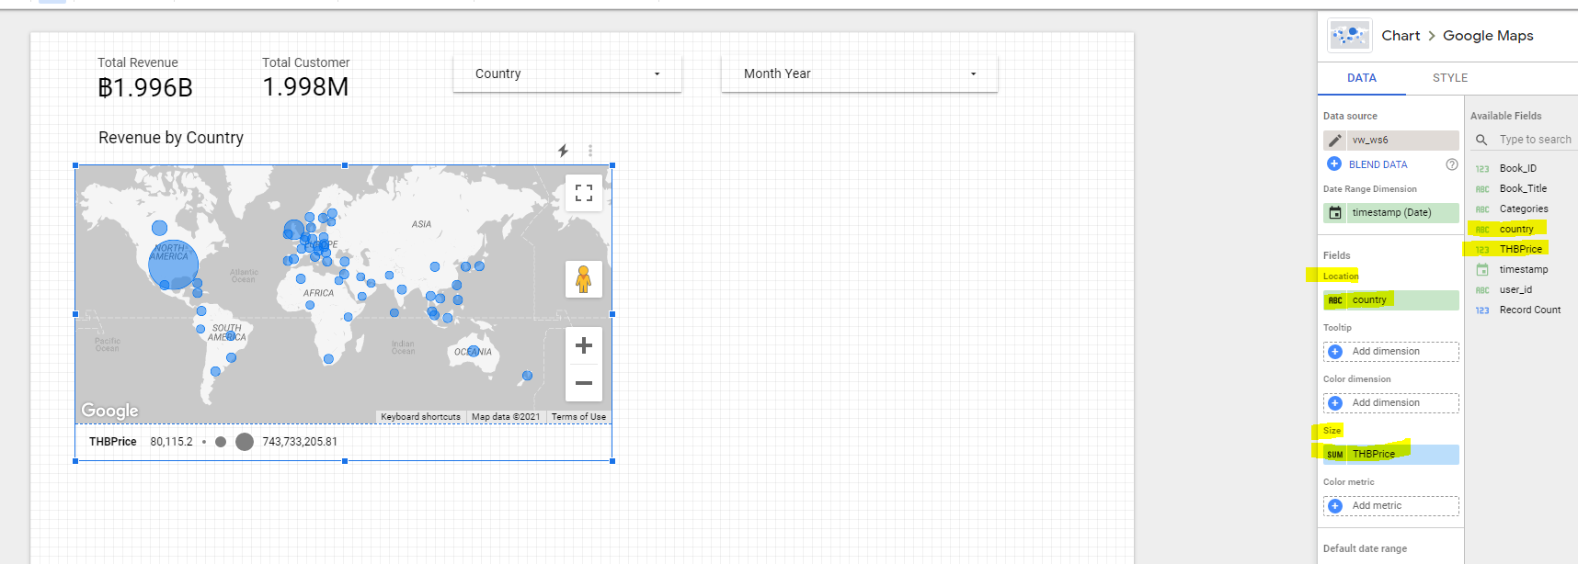

Location :Country

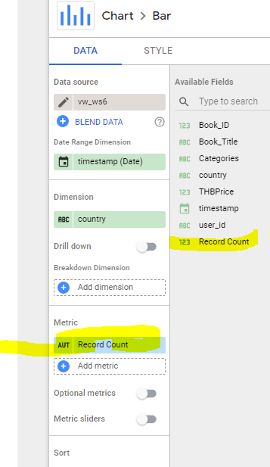Size : THBPrice

Insert > Text > Transaction by Country

Add chart > Bar

Metric : Record count

Insert > Text > Best Selling Books

Add chart> Table with bar

Dimension : ABC Book_Title

Metrick : Sum Revenue

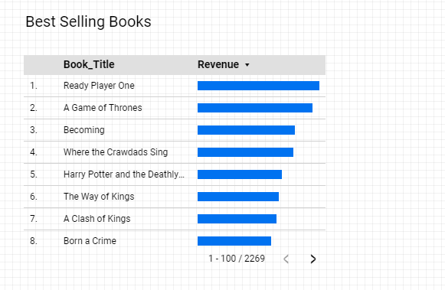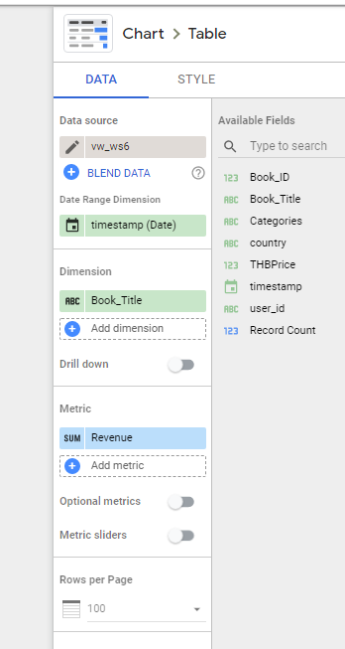

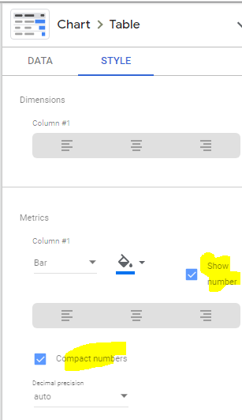

Insert > Text > Best Selling by Categories

Add cart > Tree map

Mertric : THB price >

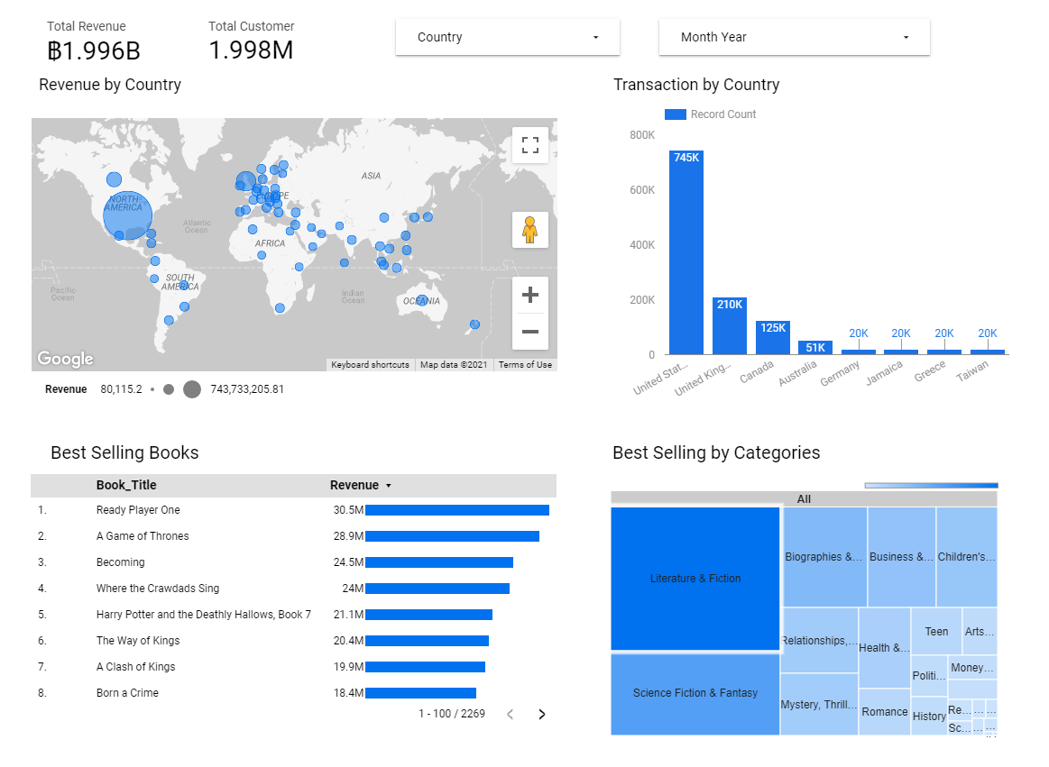

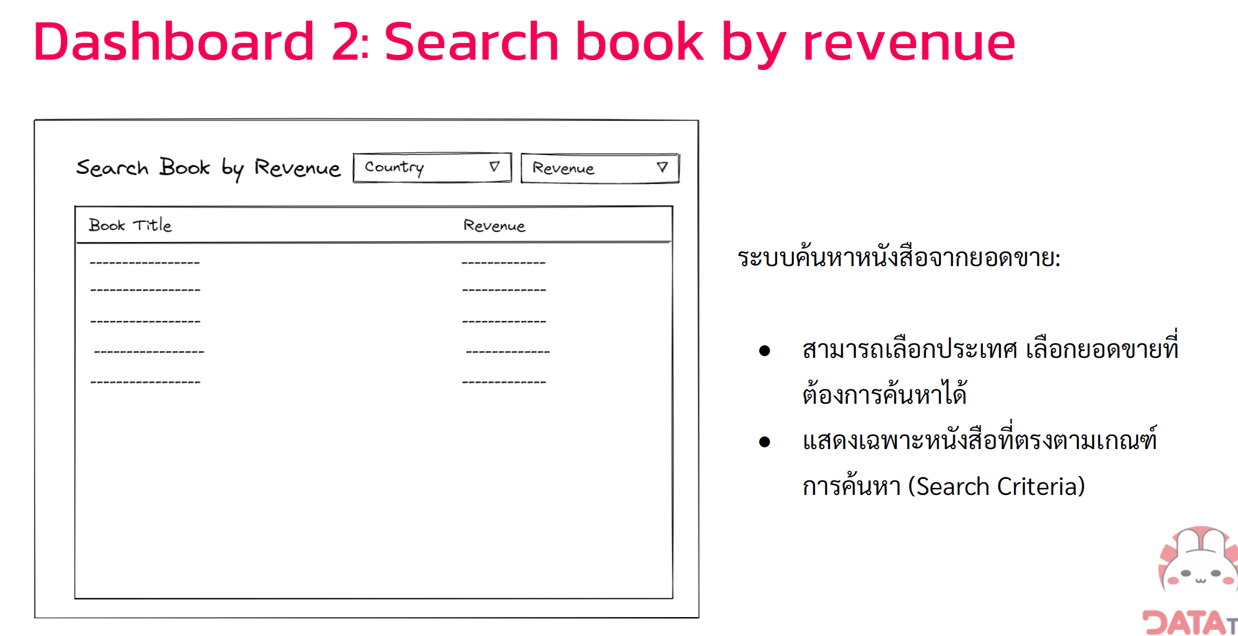

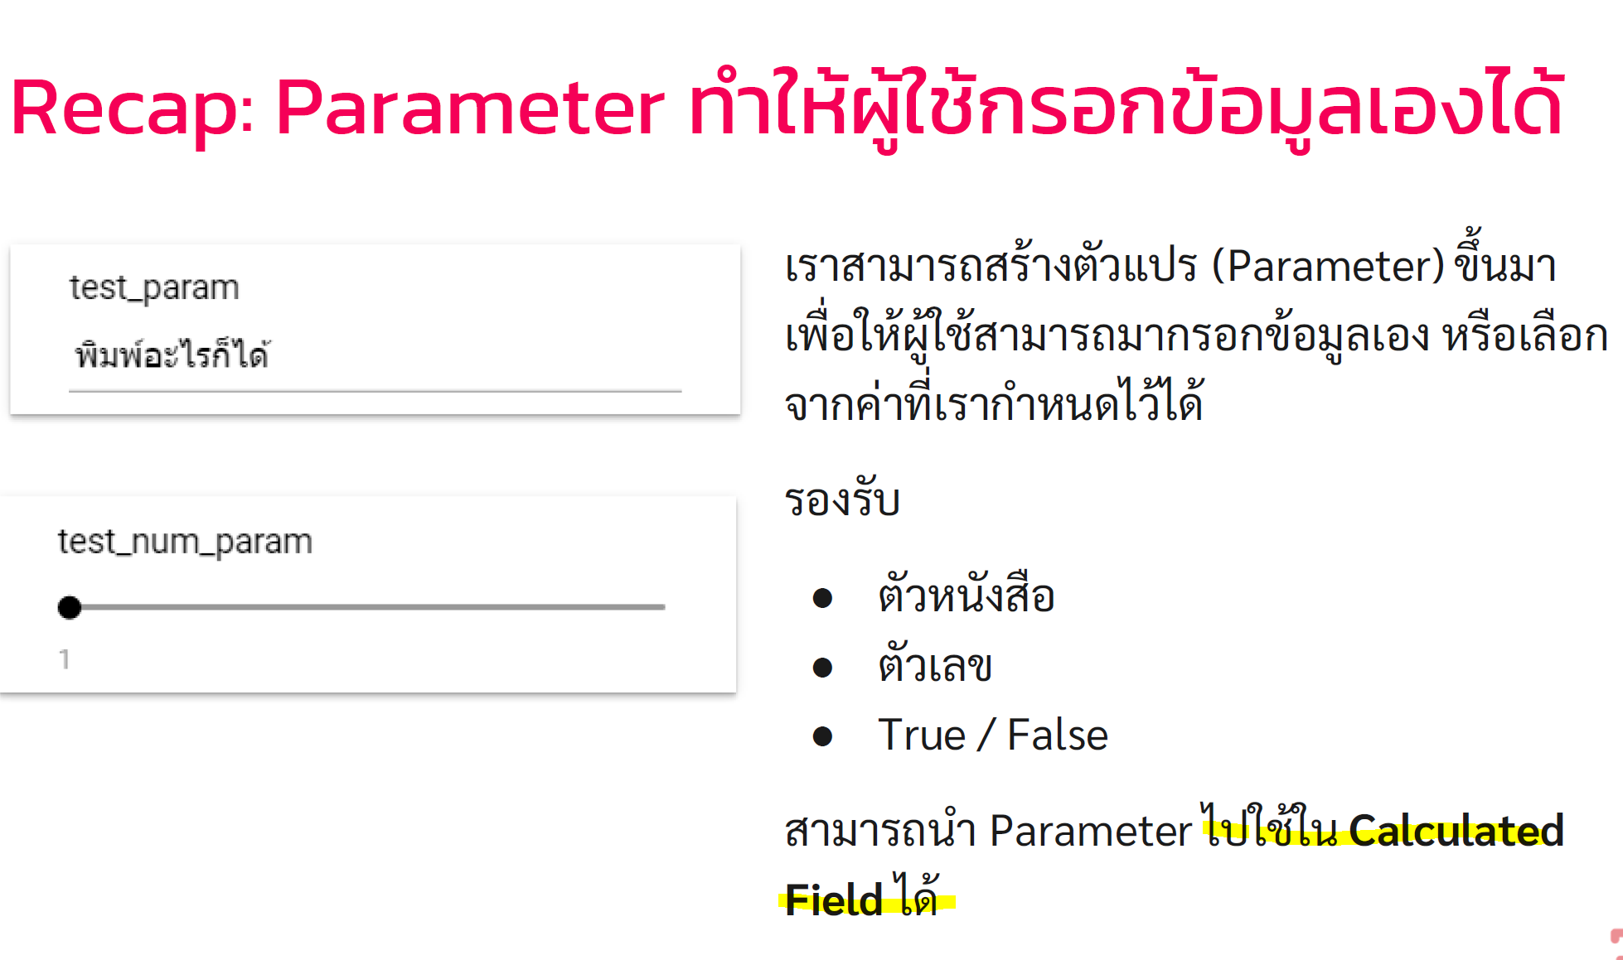

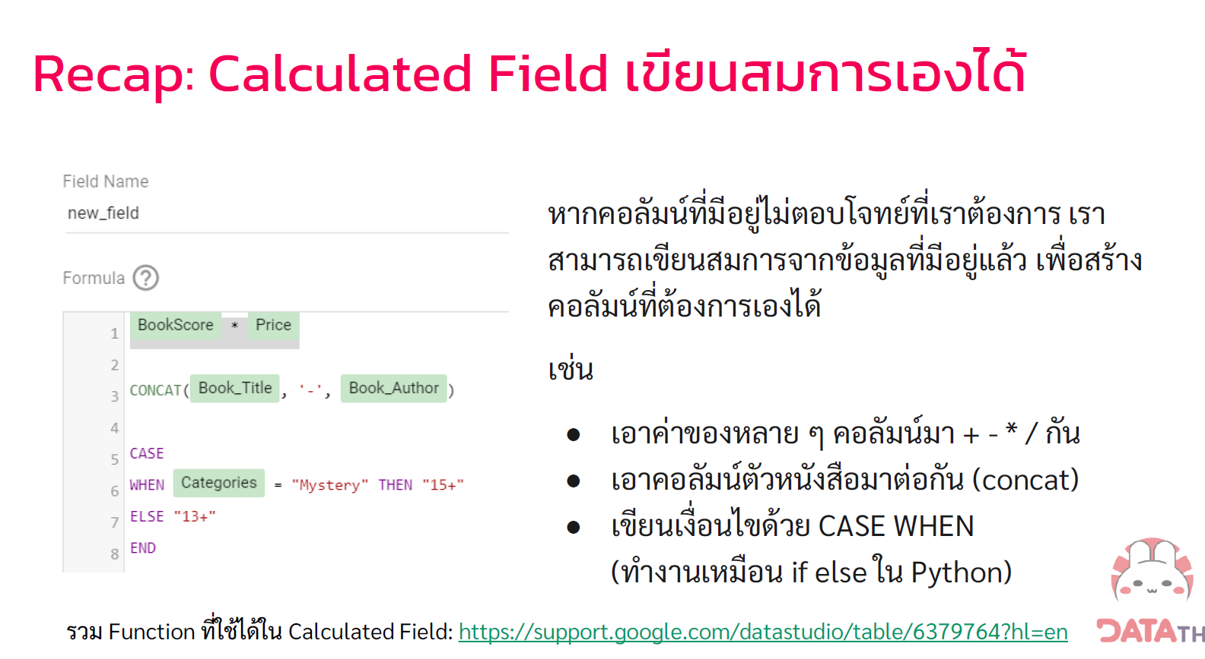

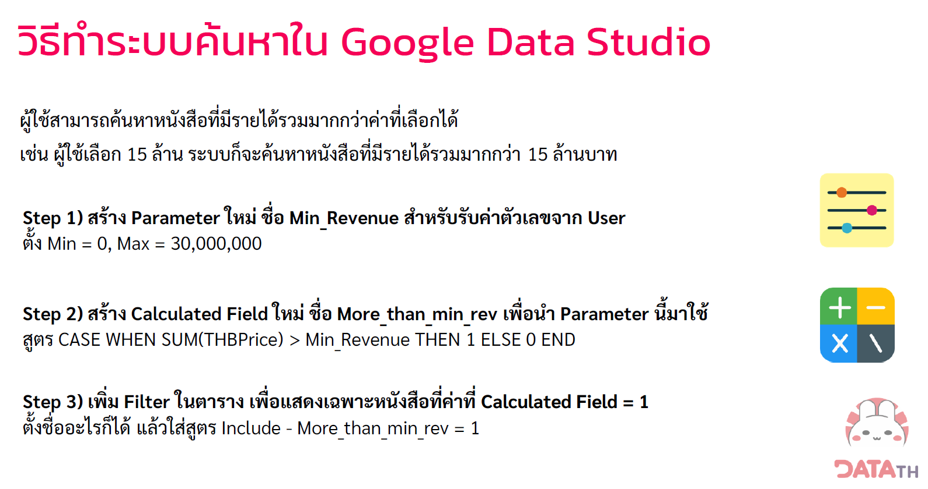

สร้าง page2

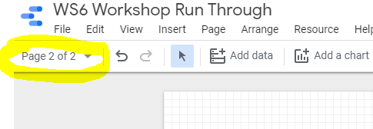

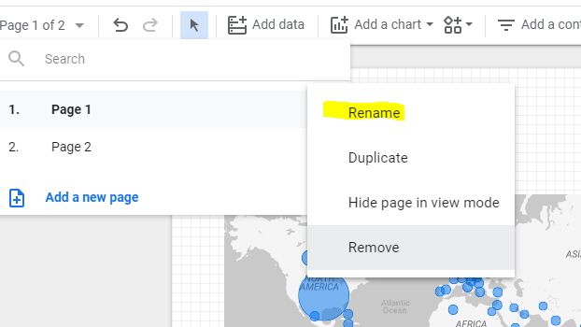

Rename Page1 > Overview

Page2 > Search & Filter

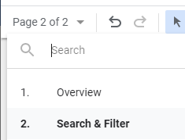

ลาก > Group

Copy

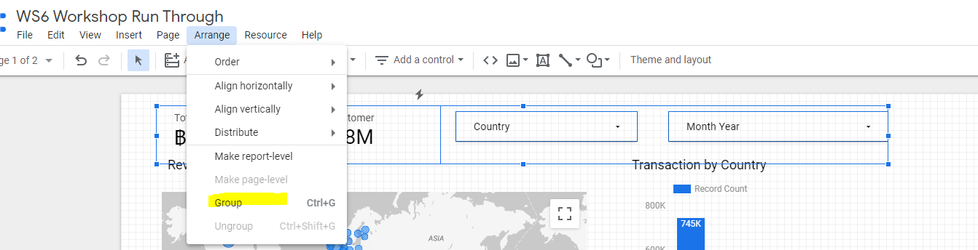

วางใน Page 2

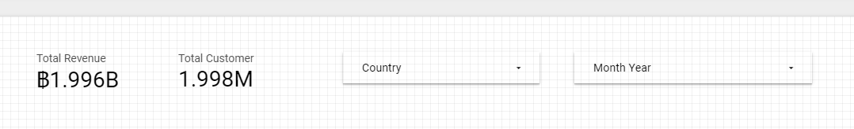

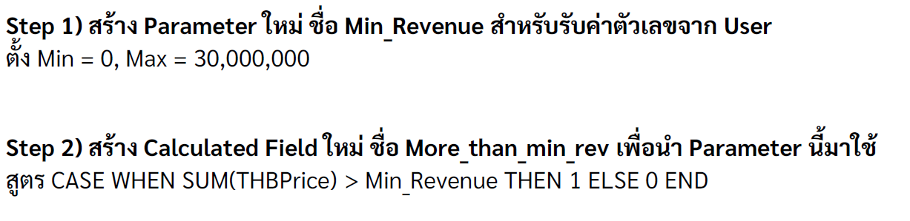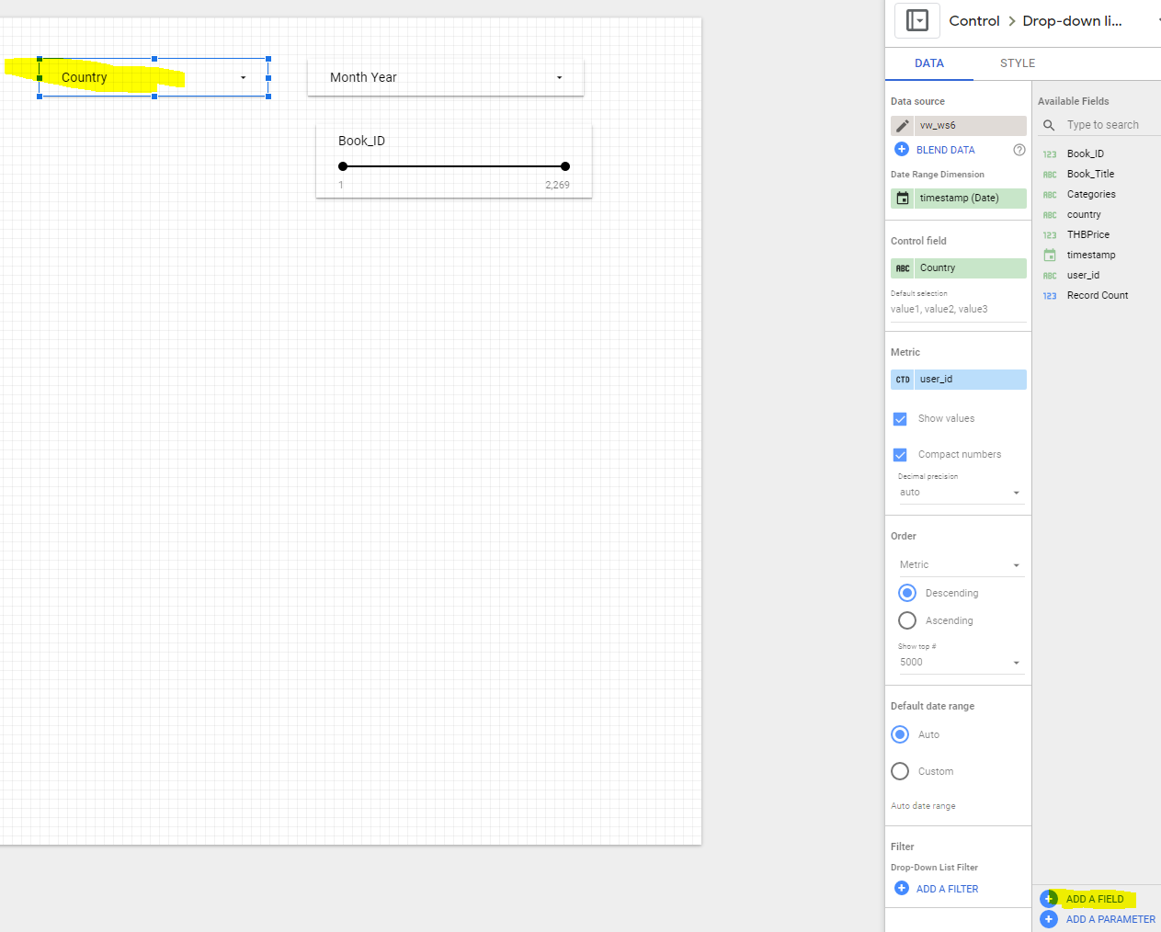

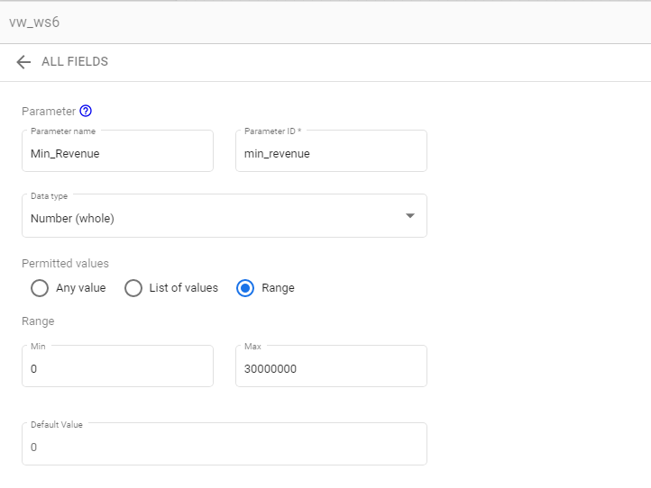

Add a control > Slider

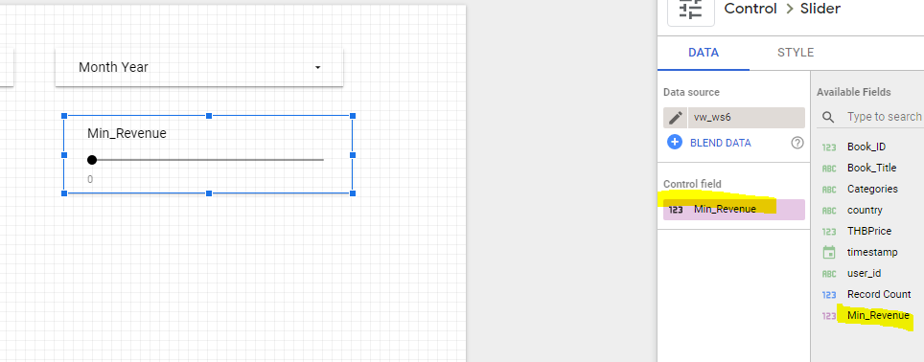

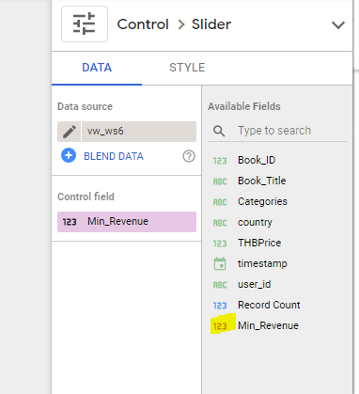

Add Field

CASE WHEN SUM(THBPrice)> Min_Revenue THEN 1 ELSE 0 END

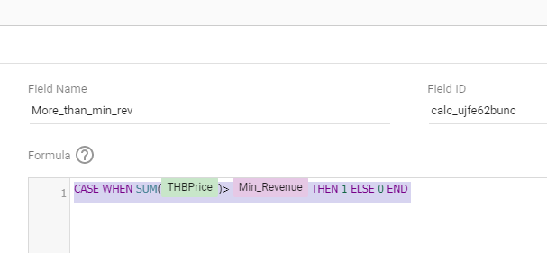

Add chart > Table

